**How to Download & Prep Foreclosure Data**

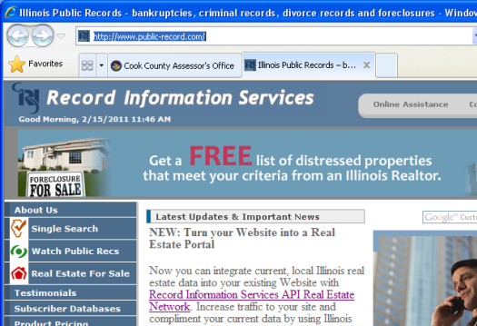Foreclosure data comes from RIS (Record Information Services). Our contact person there is Jeff Metcalf, p: 630-557-1000 x216, [jmetcalf@public-record.com](mailto:jmetcalf@public-record.com).

1. Go to <http://www.public-record.com/> .
2. Click on “Subscriber Databases”.
3. Click on “Cook Foreclosures”. You may need to scroll down the page to find the Foreclosures & Auction section.

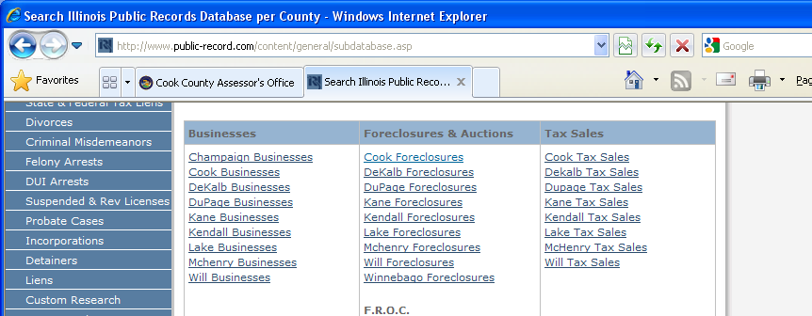

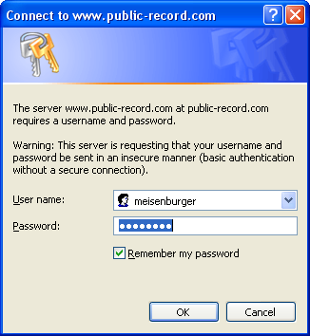

1. Enter login information:

User name: meisenburger

Password: assessor

1. The initial login page shows you your last login, how much data you have downloaded, and other non-essential information. Click “Next” at the bottom of the page.

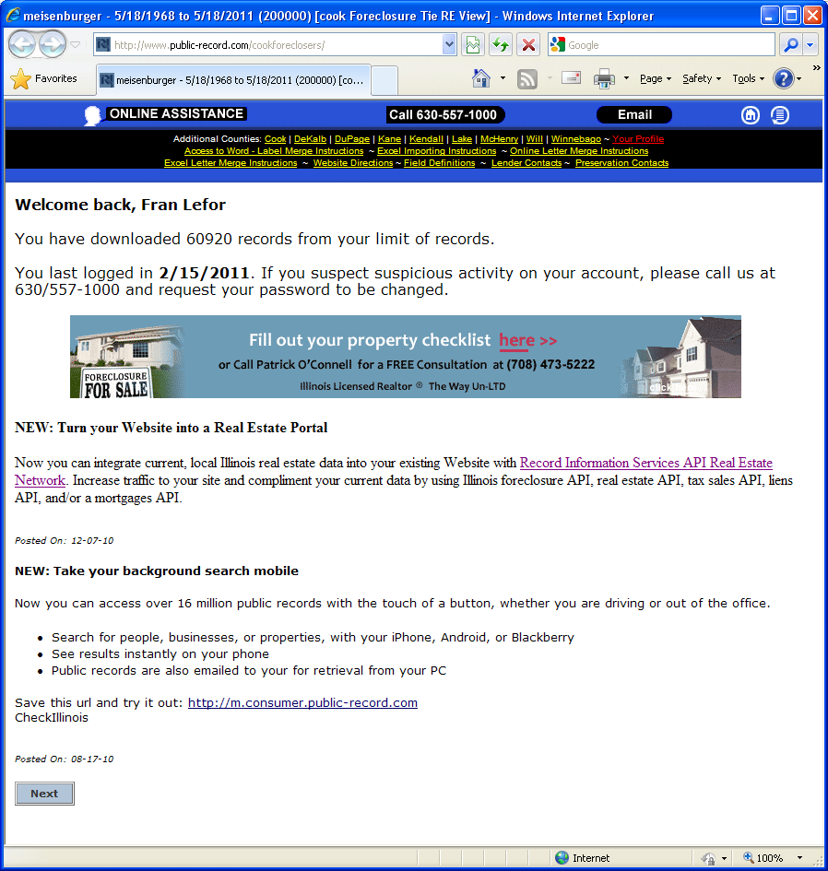

1. At this point, you need to decide whether you will be downloading **foreclosure filings** or **completed foreclosures** (aka **REOs**).
   1. For **foreclosure filings**:
      1. Enter the range of dates you want in the **“Input Date”** field.
      2. Select “Newly Filed Foreclosure” in **“Type of Foreclosure”** field.
      3. Do not select anything on any of the other fields.
      4. Click **“Find Data”** at bottom of page.

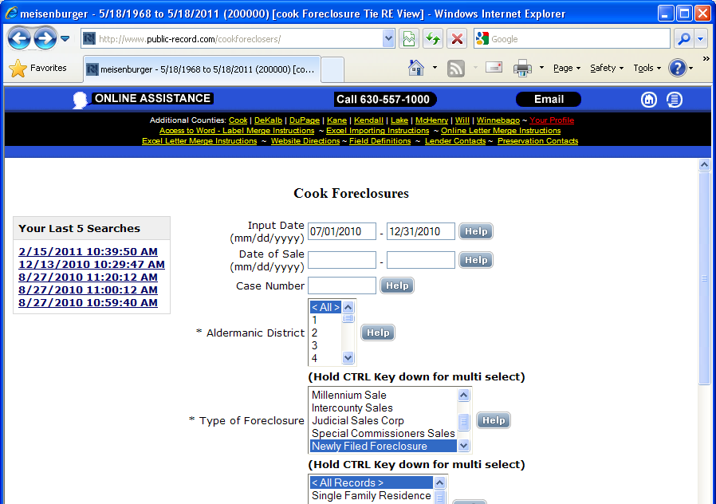

…

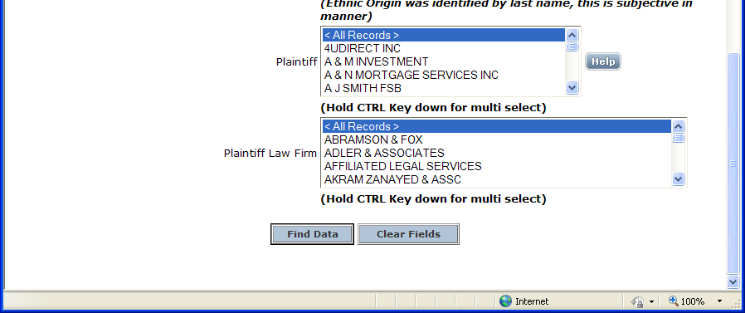

* 1. For **completed foreclosures/REOs**:
     1. Enter the range of dates you want in the **“Date of Sale”** field.
     2. Select “Sheriff Sales”, “Kallen Financial”, and all other sale types *except* “Newly Filed Forelcosure” in **“Type of Foreclosure”** field. Hold down the Ctrl key while clicking to select multiple sale types.
     3. Do not select anything on any of the other fields.
     4. Click **“Find Data”** at bottom of page.

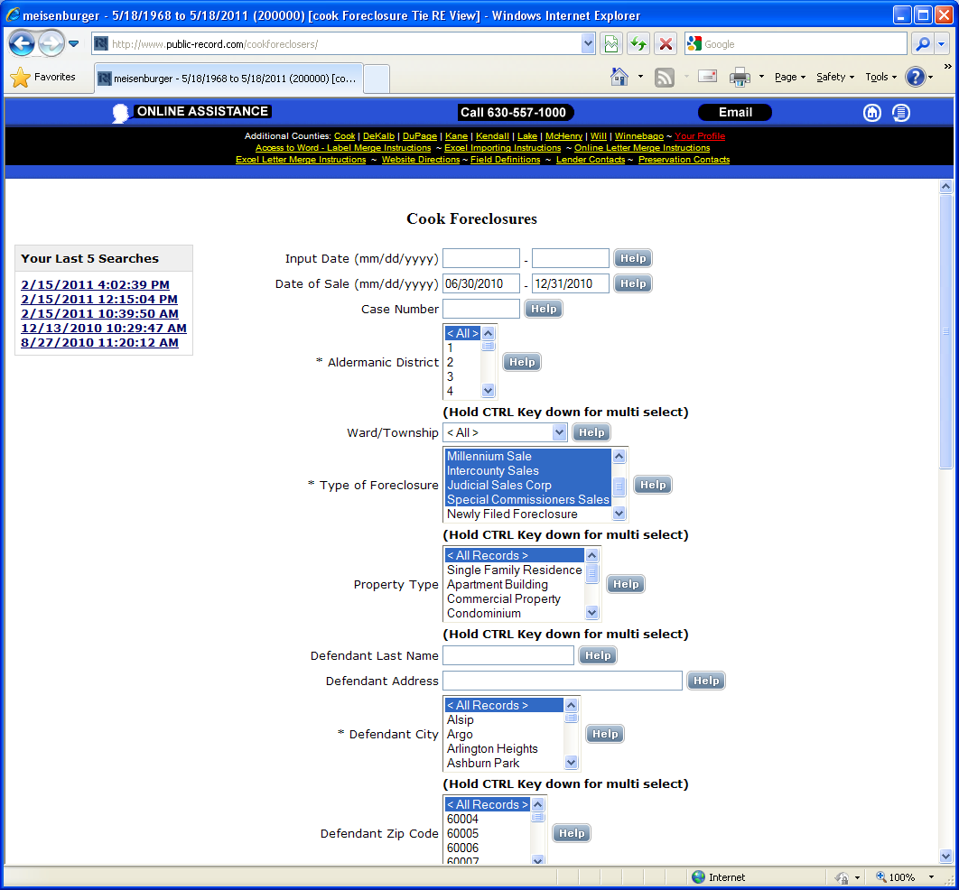

…

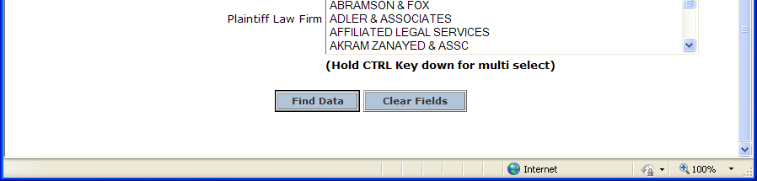

1. Now you **choose which data fields you’d like** for each property. There are many fields which are completely irrelevant. First click “Uncheck All”, then click on the check box next to each field you’d like to download.

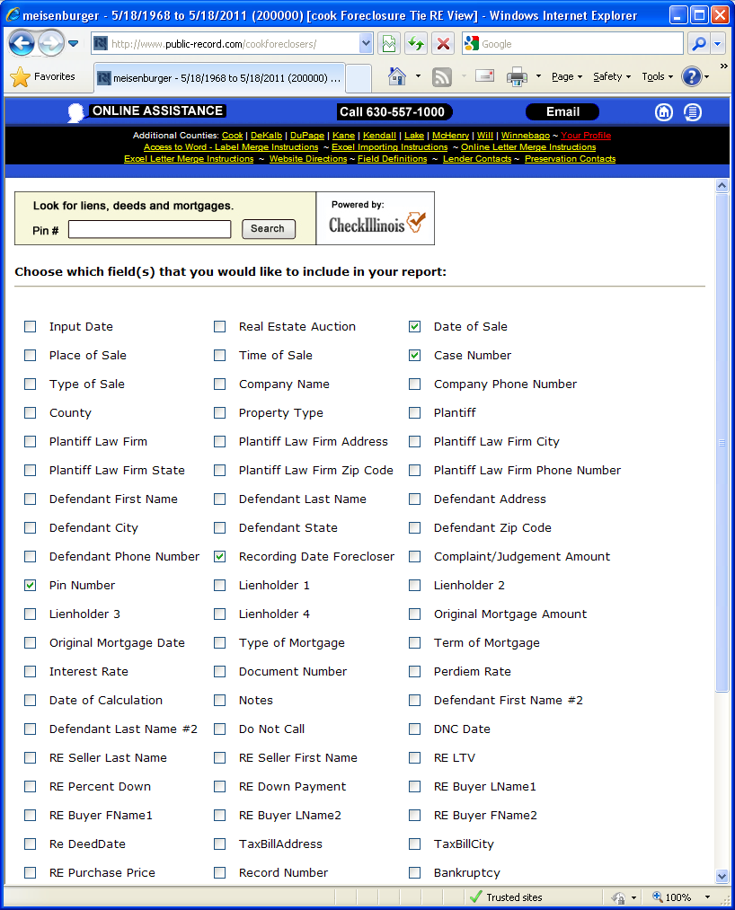

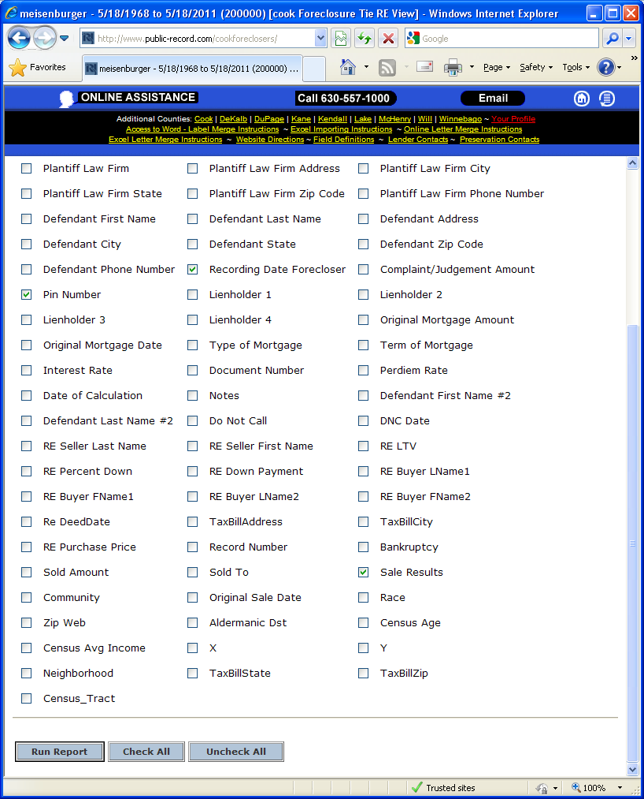

1. Click “Run Report”.
2. 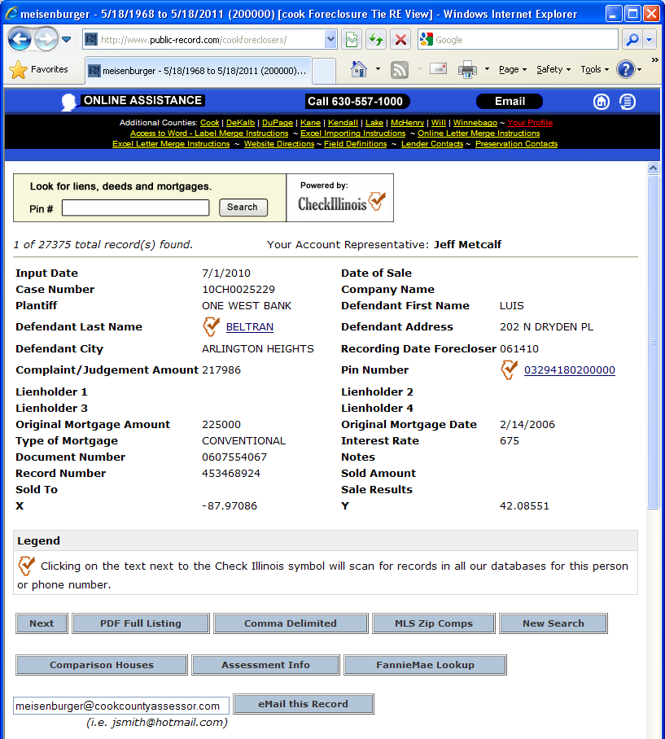Choose what type of file you’d like to download, either “Comma Delimited” or “Excel Format”. There is an SPSS syntax to translate the comma delimited text file, so I’d recommend that one.

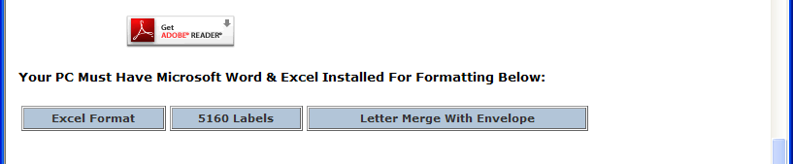

1. 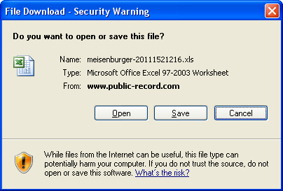When security warning appears, click “Open”, not “Save”.

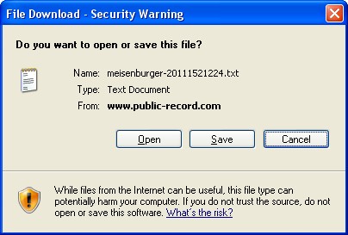

1. This will open either a text file or an excel file. Save that file!

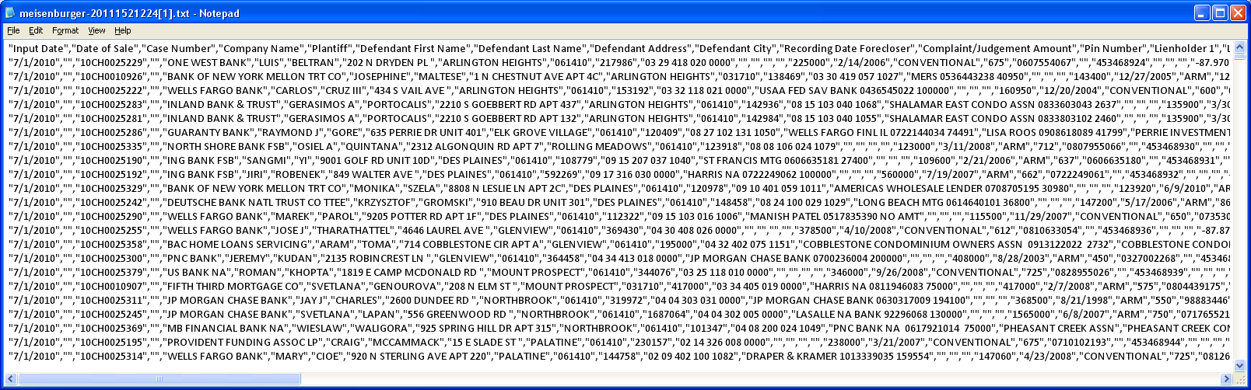

I have saved previous downloads at O:\Foreclosures\RIS data files\

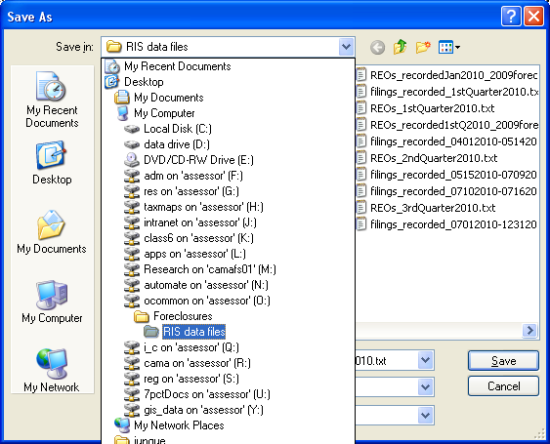

1. At this point, the **text file needs to be translated into an SPSS file**. I’ve written syntax for SPSS that will do this for you; you just need to change the file paths before running the syntax.
   1. Open the syntax from O:\Foreclosures\RIS data files\RIS_data_translate.sps.

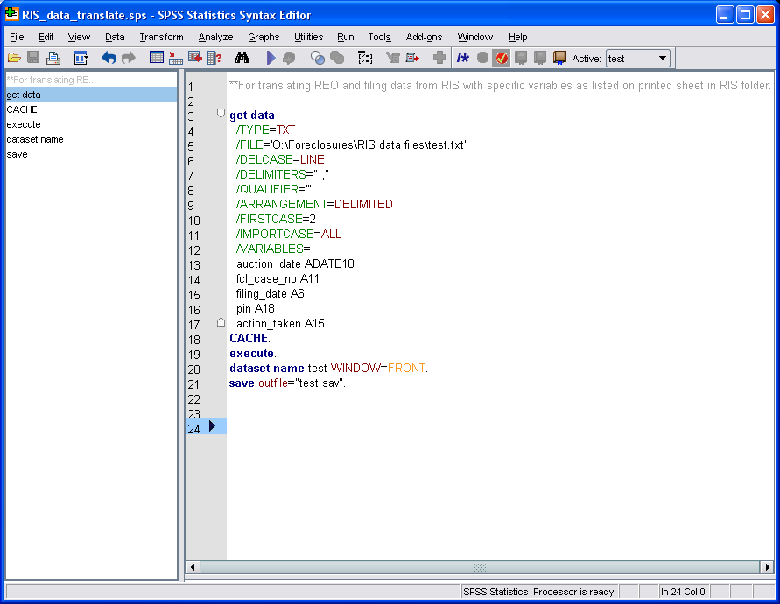

* 1. Change the path names at the two places indicated

Line 5: /FILE=‘*enter full path name here for text file*’

Line 44: save outfile=“*enter full path name here for location and name of new file*”

* 1. Once you’ve update the paths, run the syntax. The data is now in SPSS format.

1. 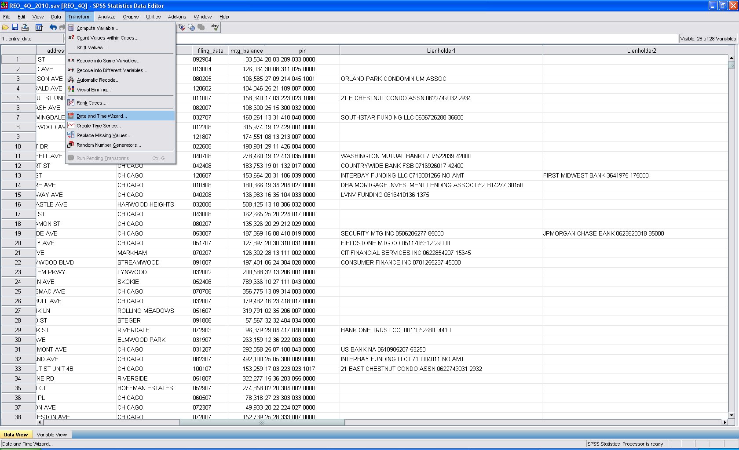Now **the data needs to be cleaned up a bit**.
   1. Convert *filing_date* variable from numeric to date format (071208 needs to be 07/12/08). The easiest way I know how to do this is through the drop-down menus.
      1. Click on *Transform* menu, and choose *Date and Time Wizard*.
      2. 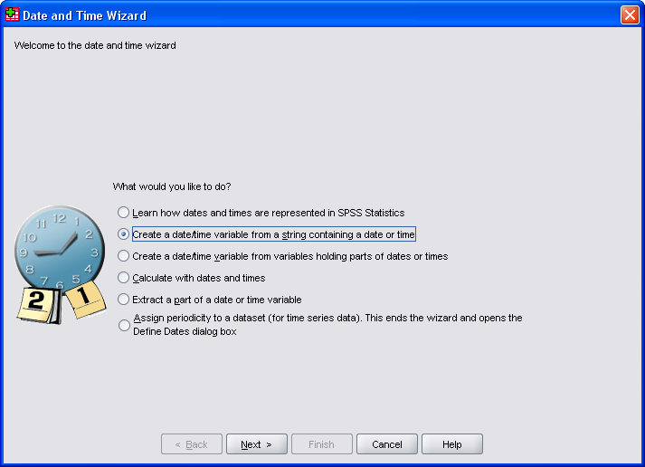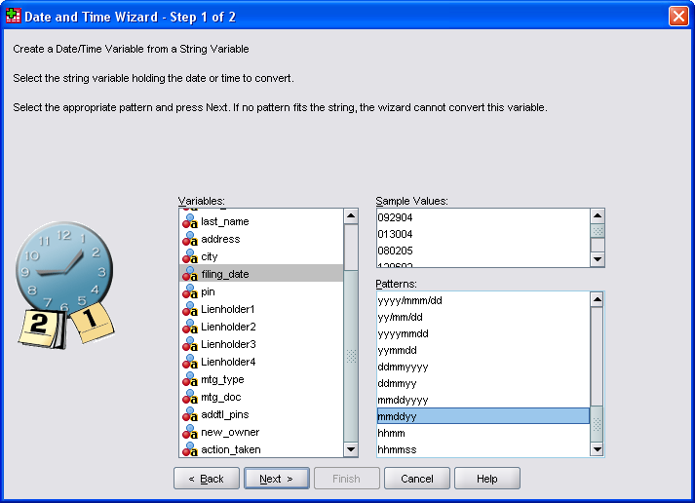Choose the button to create a date from a string, and then click “Next”*.*
      3. Click on *filing_date* in the *Variables* column, and then scroll to the bottom of the *Patterns* section and choose *mmddyy*. Click “Next”. Click “OK” to pop up.

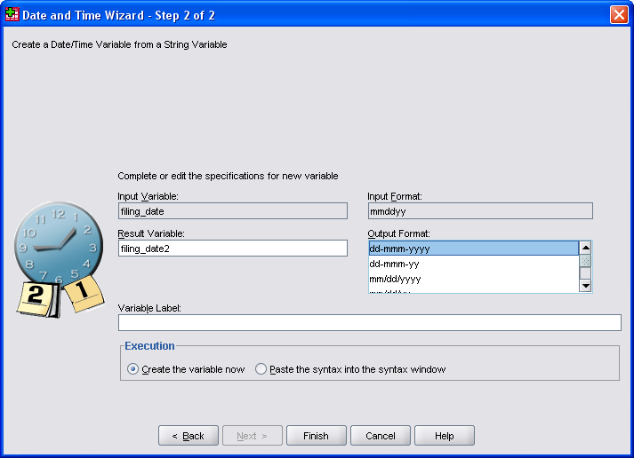

* + 1. Type “filing_date2” into *Result Variable* box. Choose *dd-mmm-yyyy* or whatever date format you prefer in the *Output Format* area. Click “Finish”.
    2. 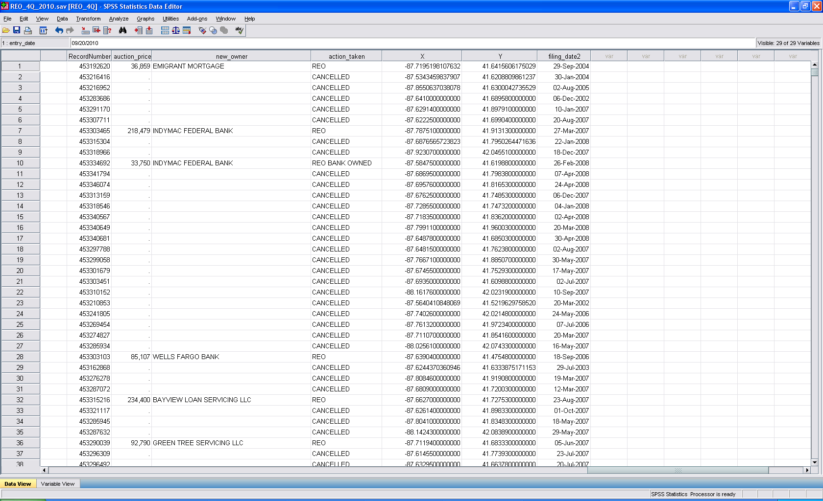Double check to make sure *filing_date2* looks like a date, then delete original *filing_date* variable. Rename the *filing_date2* variable to *filing_date.*
  1. 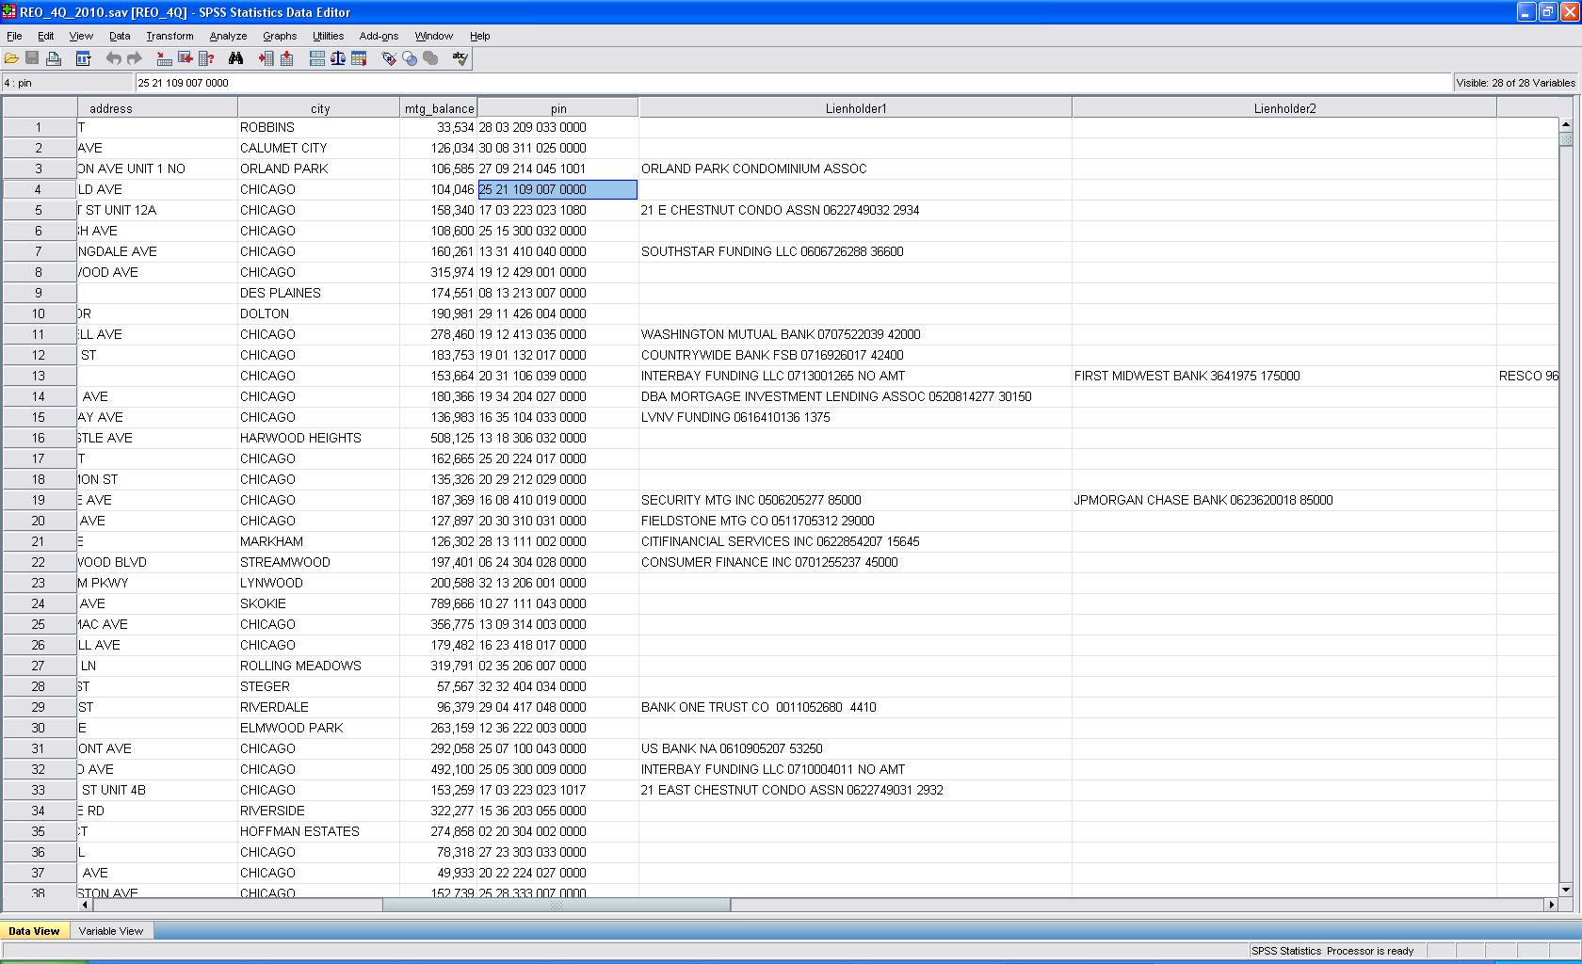The *pin* variable is currently a text variable with extra spaces. To remove those spaces:
     1. Select the entire *pin* column.
     2. Click on the “Edit” menu and choose “Replace”.
     3. 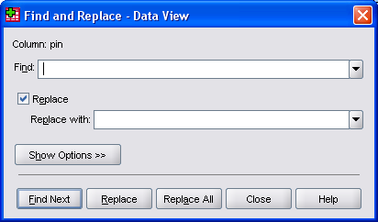In the “Find” box, type a space. Make sure “Replace” is checked, and leave the “Replace with” box empty.
     4. Click “Replace All”.
     5. 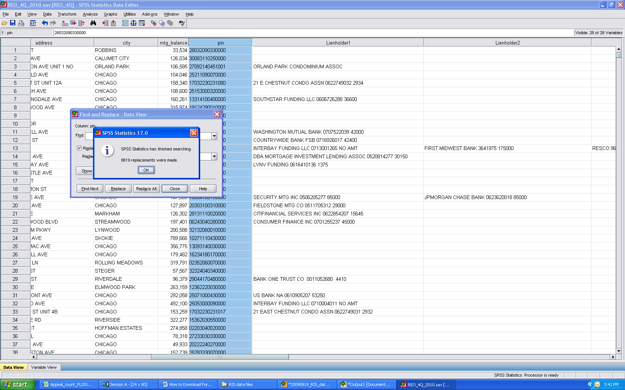The replace function may take a while to run, so sit patiently, and wait for a pop up to tell you that it has finished processing and x number of replacements were made.
     6. 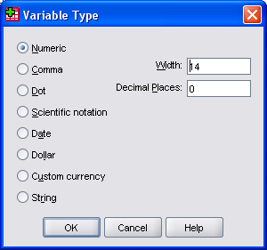Change the data type for *pin* to “Numeric” and set “Width” to 14 and “Decimal Places” to 0.

1. 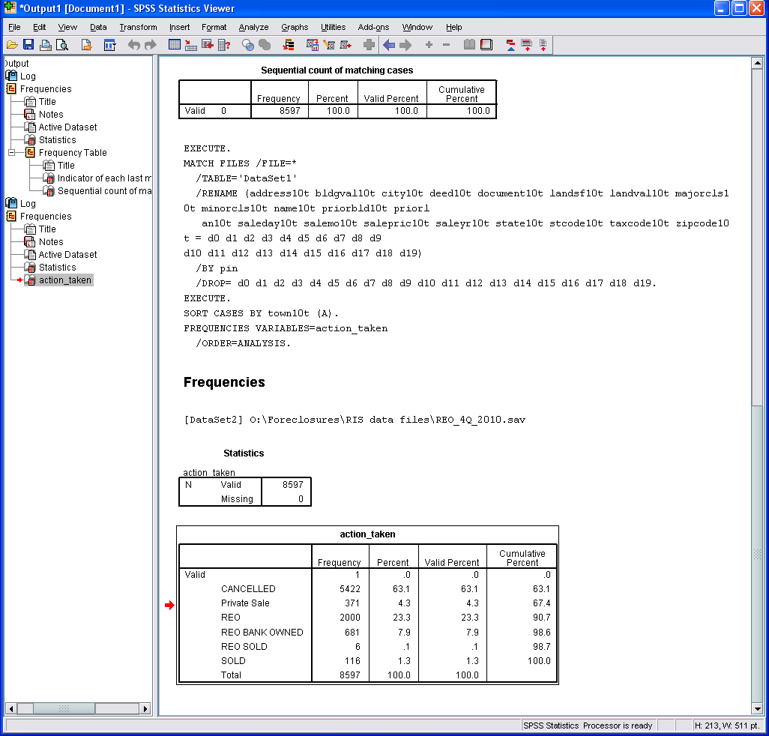**For REO datasets: Remove cancelled and rescheduled auctions.** The REO file that you download includes auctions that actually happened, and auctions that didn’t. We want only those cases that resulted in the property being foreclosed on and sold to a new owner or becoming REO.
   1. Run a frequency table on the ‘*action_taken*’ variable.
   2. The only cases you should keep are those that are ‘*REO’, ‘REO BANK OWNED’, ‘REO SOLD’, or ‘SOLD’.*
   3. There are normally a high number of cancelled sales, so the dataset will likely be much smaller once you remove them.
2. **For both datasets: Identify and remove duplicate PINs.**  Keep only most recent foreclosure auction or filing for each PIN. (We’ve considered keeping all foreclosure actions on a property, but it gets really complicated and is probably not worth the effort for our purposes).

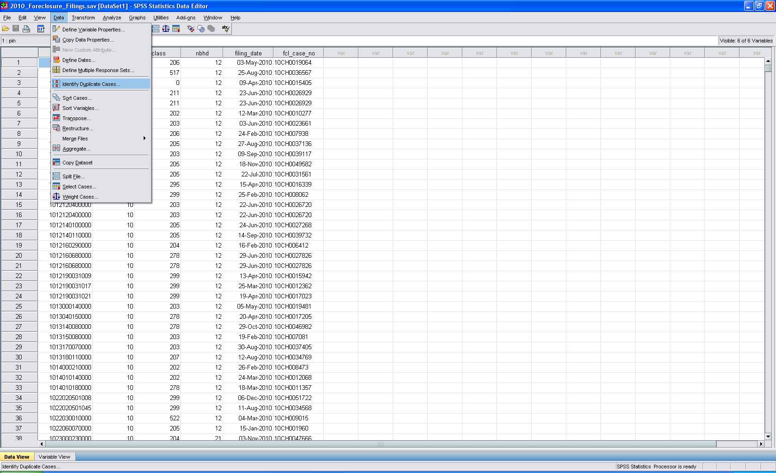 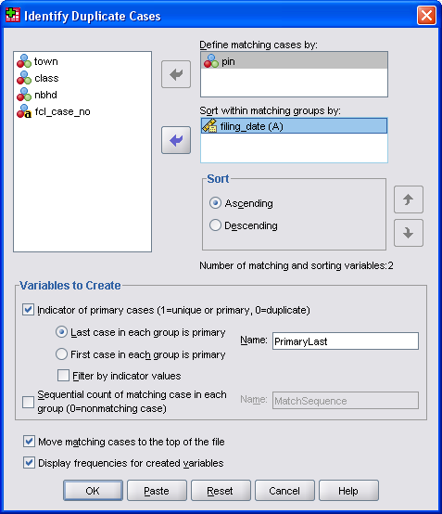

After you’ve identified the duplicate cases, select only those with PrimaryLast=1 and delete other cases.

Data -> Select Cases…

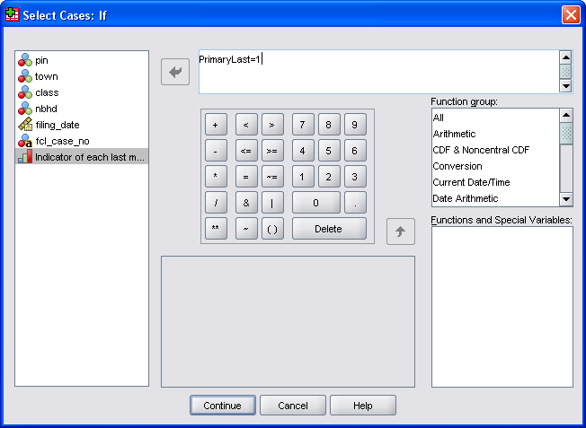

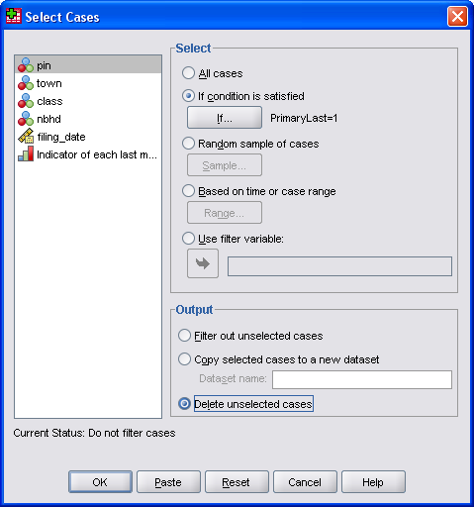

Sort by PIN (ascending order).

1. **Add in CCAO data from the most recent header file**, or whatever file you have that includes PIN, class, town, etc. (so that you have the most current list of parcels).
   1. Sort both files by PIN.
   2. Add PIN, town, and class to the foreclosure dataset, matching on PIN from the foreclosure dataset. I do this using the “Merge Files” function.
      1. Data -> Merge Files -> Add Variables…
      2. Choose “An external SPSS Statistics data file”, then click “Browse” to choose a file. Header files and other files are in O:\data.
      3. Choose a file and then click “Continue”.

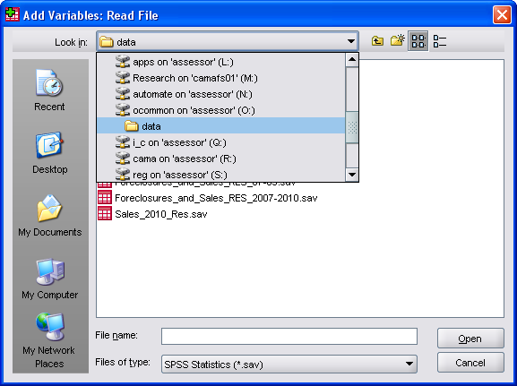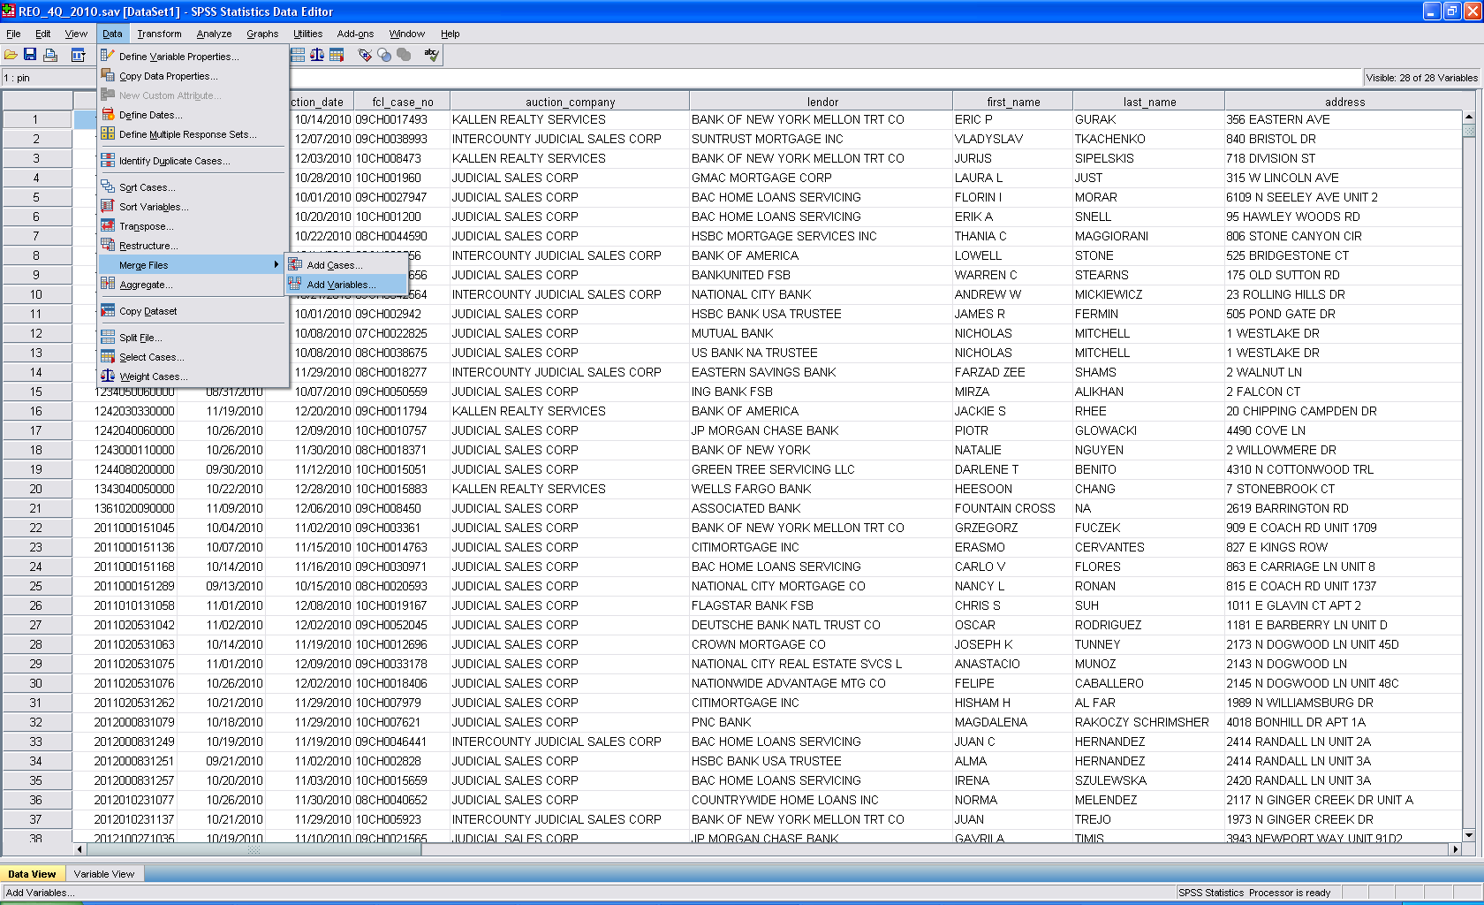

* + 1. Choose which variables from the Header file you want to include and make sure they are in the “New Active Dataset” column, then move any variables you don’t want to the “Excluded Variables” column, and match on PIN as shown below.

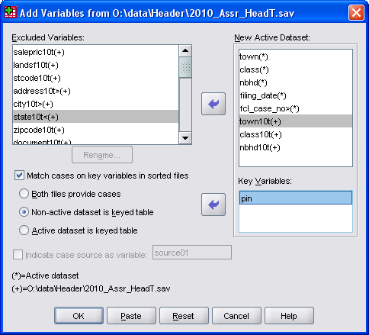

1. **Remove cases with no valid PIN.** In the past, I’ve tried to find a good PIN for all the foreclosure filings/REOs, but you can pretty safely skip this step. There aren’t usually very many foreclosures without a good PIN – in the 4th quarter there were ~200 bad PINs out of 8600.
   1. Run frequencies on town or class or something to see how many cases are missing those variables.
   2. Then select only those cases with town>0 or nbhd>0.